Practical 10: Hash Tables and Collision Handling

Practical Aim
To implement hash tables using different collision handling strategies and develop the ability to reason about why collisions occur, how different strategies resolve them, and what trade-offs each approach involves.

Problem 1
A small parking lot has exactly 10 numbered slots (0 to 9). When a vehicle arrives, its registration number is used to assign it a slot by taking the last digit of the number. If that slot is already taken, the vehicle moves to the next available slot in order, wrapping around if necessary. Given a sequence of vehicle registrations, assign each to a slot using this rule and display the final state of all ten slots.
Describe what your solution does when it encounters an already occupied slot. What happens when the parking lot is nearly full and many vehicles keep landing on the same slot? Can you think of a situation where your solution might loop indefinitely?
Code
https://github.com/AD-9218/DATA-STRUCUTURE-AND-ALGORITHM/blob/main/Practical-10/10_1.cpp
Output
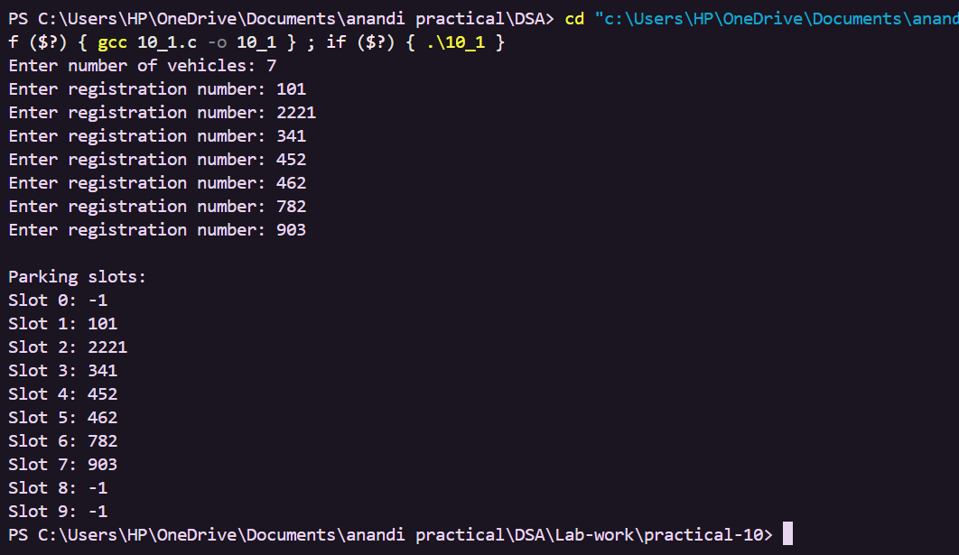

Problem 2
A library uses a system with 10 shelves numbered 0 to 9. Each book's code is used to decide which shelf it belongs to by taking the code modulo 10. Unlike the parking lot, each shelf can hold multiple books stacked together — when two books map to the same shelf, they are simply added to that shelf's stack. Given a sequence of book codes, place each on the correct shelf and display the final contents of all shelves.
Describe how your solution handles two books that map to the same shelf. What happens to search time on a shelf as more and more books pile onto it? Can you think of what would cause all books to end up on the same shelf?
Code
https://github.com/AD-9218/DATA-STRUCUTURE-AND-ALGORITHM/blob/main/Practical-10/10_2.cpp
Output
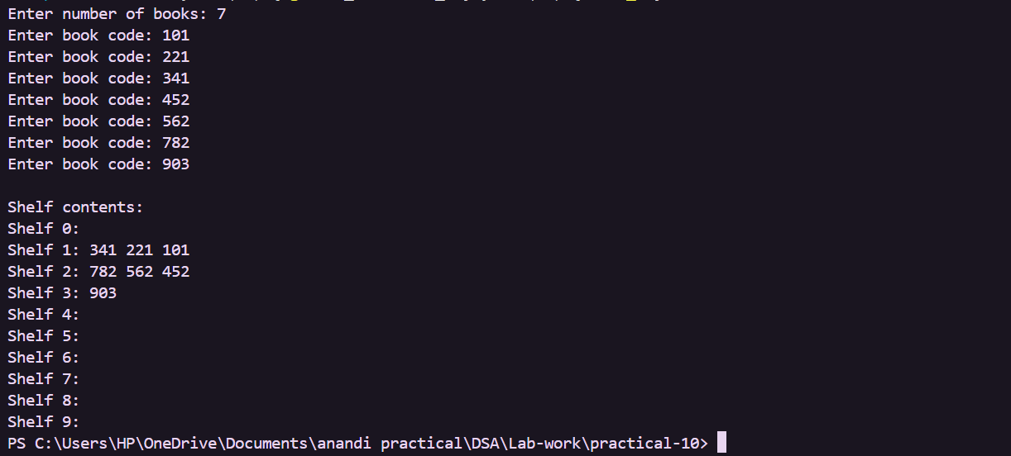

Problem 3
A university assigns student IDs to storage slots using a two-step rule. The first rule determines the initial slot. If that slot is taken, instead of simply moving one slot forward, a second rule based on the ID itself determines how many slots to jump. This means different IDs that collide will probe different sequences of slots, spreading them more evenly. Given a sequence of student IDs, assign each to a slot using both rules and display the final state of the table.
Describe how your solution decides how many slots to jump when a collision occurs. What is the risk if the jump size happens to be a factor of the table size? How does this strategy differ from Problem 10.1 in how it spreads collisions?
Code
https://github.com/AD-9218/DATA-STRUCUTURE-AND-ALGORITHM/blob/main/Practical-10/10_3.cpp

Output
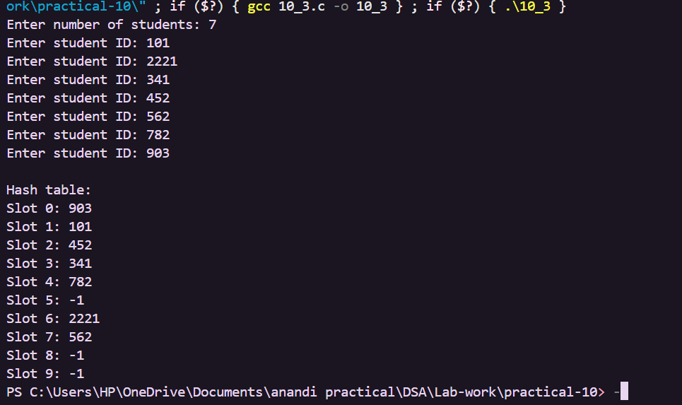

Key Questions / Analysis / Interpretation to be Evaluated During/After Implementation
1. [Problem 1] If five consecutive vehicle registrations all end in the same digit, trace where each one gets placed in the parking lot. Now explain why this clustering effect is a structural weakness of this collision strategy — not just for this input, but in general.
Answer: With linear probing, the first vehicle is placed at the hashed slot. Each following vehicle that gets the same slot moves to the next available slot, so the vehicles occupy consecutive slots. This creates clustering because a group of occupied consecutive slots makes later collisions search through the same group, increasing the number of probes.
2. [Problem 2] Suppose all book codes in Problem 2 are within 10. Without tracing through the code, predict what the final shelf layout would look like and explain why. What does this tell you about the relationship between the hash function and the input data?
Answer: If all book codes are within 10, each code modulo 10 produces its own code as the shelf index. Therefore each book goes directly to the shelf with the same number as its code. This shows that the distribution of input values and the hash function together determine how evenly data is spread across the table.

3. [Problem 3] What would happen if the second rule always produced a jump size of zero? Trace through the consequence and explain how this failure is related to the choice of the second hash function rather than the data itself.
Answer: A jump size of zero would keep the probe at the same slot after a collision. The program would keep checking the occupied slot and could loop indefinitely. This is a failure of the second hash function because it does not provide a valid alternative position for probing.

